Chapter 3 Problems
Problem 1.
source port numbers destination port numbers
a) A->S 4467 23
b) B->S 5513 23
c) S->A 23 4467
d) S->B 23 5513
e) Yes.
f) No.

Problem 2.

Suppose the IP addresses of the hosts A, B, and C are a, b, c, respectively. (Note that a,b,c are distinct.) To host A: Source port =80, source IP address = b, dest port =26145, dest IP address = a To host C, left process: Source port =80, source IP address = b, dest port = 7532, dest IPaddress = c To host C, right process: Source port =80, source IP address = b, dest port = 26145, dest IP address = c

Problem 5.
To best answer this question, consider why we needed sequence numbers in the first place. We saw that the sender needs sequence numbers so that the receiver can tell if a data packet is a duplicate of an already received data packet. In the case of ACKs, the sender does not need this info (i.e., a sequence number on an ACK) to tell detect a duplicate ACK. A duplicate ACK is obvious to the rdt3.0 receiver, since when it has
received the original ACK it transitioned to the next state. The duplicate ACK is not the ACK that the sender needs and hence is ignored by the rdt3.0sender.
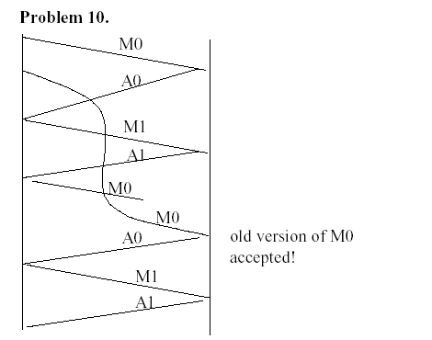
Problem 15.

This problem is a variation on the simple stop and wait protocol (rdt3.0). Because the channel may lose messages and because the sender may resend a message that one of the receivers has already received (either because of a premature timeout or because the other receiver has yet to receive the data correctly), sequence numbers are needed. As in rdt3.0, a 0-bit sequence number will suffice here. The sender and receiver FSM are shown in the next Figure. In this problem, the sender state indicates whether the sender has received an ACK from B (only), from C (only) or from neither C nor B. The receiver state indicates which sequence number the receiver is waiting for.

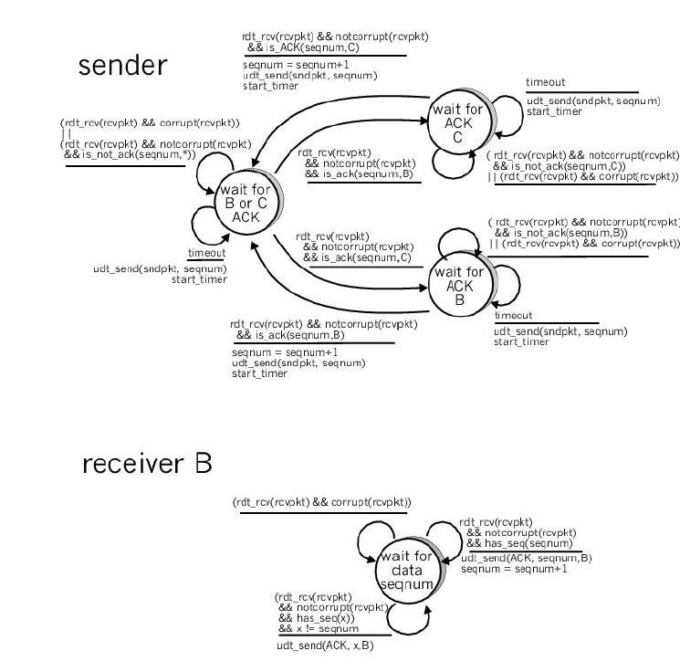

Problem 19.

a) True. Suppose the sender has a window size of 3 and sends packets 1, 2, 3 at 0 t . At 1 t ) 0 1 ( t t > the receiver ACKS 1, 2, 3. At 2 t ) 1 2 ( t t > the sender times out and resends 1, 2, 3. At 3 t the receiver receives the duplicates and re-acknowledges 1, 2, 3. At 4 t the sender receives the ACKs that the receiver sent at 1 t and advances its
window to 4, 5, 6. At 5 t the sender receives the ACKs 1, 2, 3 the receiver sent at 2 t . These ACKs are outside its window.
b) True. By essentially the same scenario as in (a).
c) True.
d) True. Note that with a window size of 1, SR, GBN, and the alternating bit protocol are functionally equivalent. The window size of 1 precludes the possibility of out-of-order packets (within the window). A cumulative ACK is just an ordinary ACK in this
situation, since it can only refer to the single packet within the window.

